SUPPLEMENTARY MATERIAL

Supplementary Table 1. Risk of bias assessment based on ROBINS-I¹⁴
Study，publication year | Bias due to confounding | Bias in selection of  participants | Bias in  measure  ments of  interventions | Bias due to  departures from  intended  interventions | Bias due to  missing  data | Bias in  measure  ments of  outcomes | Bias in  selection of  reported  result | Overall bias
Peng J,2015¹⁷ | N | N | N | N | N | PN | N | Low
Buti M,2015¹⁸ | Y | PY | N | N | N | N | N | Serious
Fontaine H,2015¹⁹ | Y | PY | N | N | N | N | N | Serious
Chen L,2015²⁰ | N | N | N | N | PN | N | N | Low
Hsu YC,2016²¹ | N | PN | N | N | N | N | N | Low
Park CH,2016²² | PY | PY | N | N | N | PY | PY | Serious
Jun BG,2016²³ | N | PN | PN | PN | N | N | N | Moderate
Lin CC,2016²⁴ | N | N | N | N | PN | PY | PY | Serious
Nagata N,2016²⁵ | N | N | N | PN | N | PY | PN | Serious
Lee HA,2016²⁶ | N | N | PN | N | PN | N | N | Moderate
Siederdissen CH,2016²⁷ | PN | PN | N | N | N | N | PN | Moderate
Siederdissen CH,2016²⁸ | PY | PN | N | N | N | N | PY | Serious
Muche M,2017²⁹ | PN | PY | N | N | N | N | PN | Serious
Karakaya F,2017³⁰ | N | N | PN | N | N | N | N | Low
Cao JW,2017³¹ | N | N | PN | N | PN | N | N | Moderate
Berg T,2017³² | N | N | PN | PN | N | N | N | Moderate
Jeng WJ,2018³³ | PY | N | N | PN | N | N | PN | Serious
Dalekos GN,2018³⁴ | N | N | PN | PN | PN | N | N | Moderate
Papatheodoridis GV,2018³⁵ | N | N | PY | PN | N | N | N | Serious
Rivino L,2018³⁶ | PN | N | PY | PN | PN | N | N | Serious
Chi H,2018³⁷ | PN | N | PN | N | N | PN | N | Moderate
Liu F,2018³⁸ | N | PN | N | PN | N | N | N | Moderate
Hsu YC,2018³⁹ | N | N | PY | PY | N | N | PN | Serious
Kranidioti H,2019⁴⁰ | PY | PY | PN | N | PN | N | N | Serious
Hees SV,2019⁴¹ | PY | PN | PN | PN | N | PY | N | Serious
Xie LQ,2019⁴² | PN | N | N | PN | N | PN | N | Moderate
N: no, PN: probably no, PY: probably yes, Y: yes.

SUPPLEMENTARY FIGURE LEGENDS
Supplementary Figure 1. Flow chart of study search and selection
Supplementary Figure 2. Forest plots of overall probabilities of biochemical relapse (BR) after NAs cessation. A: All patients, B: HBeAg-positive patients, C: HBeAg-negative patients. ES means effect size, which refers to estimated probability.
Supplementary Figure 3. The rates of off-NAs biological relapse (BR) during follow-up after NAs cessation. A: All patients, B: HBeAg-positive patients, C: HBeAg-negative patients. Bars are 95% CI. Green lines are trend lines.
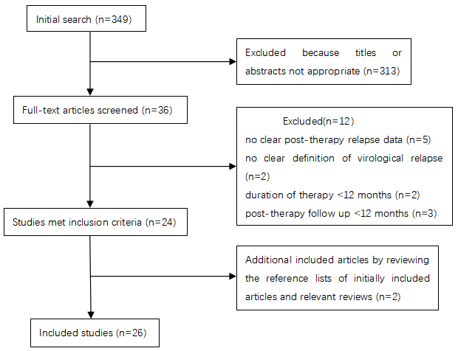
Supplementary Figure 1. Flow chart of study search and selection

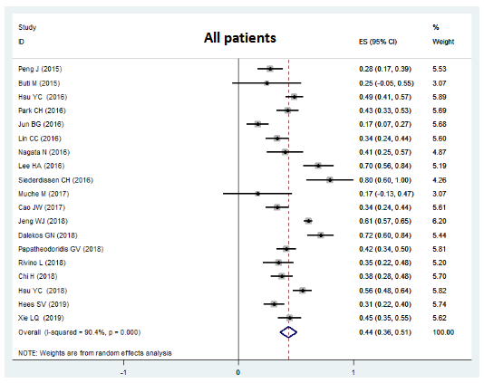
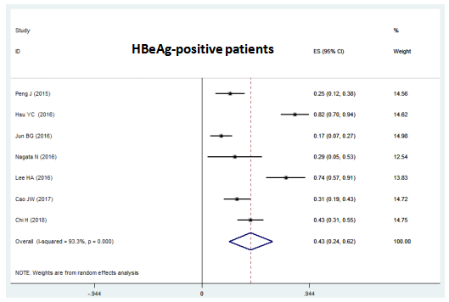
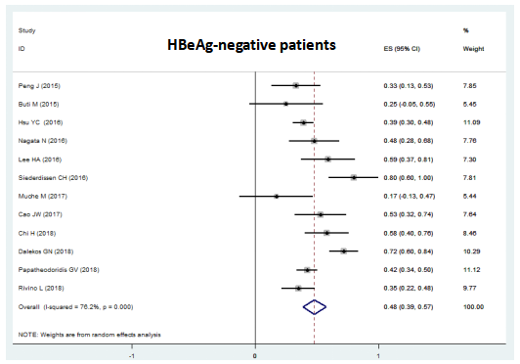
Supplementary Figure 2. Forest plots of overall probabilities of biochemical relapse (BR) after NAs cessation. A: All patients, B: HBeAg-positive patients, C: HBeAg-negative patients. ES means effect size, which refers to estimated probability.

Supplementary Figure 3. The rates of off-NAs biological relapse (BR) during follow-up after NAs cessation. A: All patients, B: HBeAg-positive patients, C: HBeAg-negative patients. Bars are 95% CI. Green lines are trend lines.

